satellite biomass analytics
Descriptive, Predictive and Perspective Analytics

Student: Yazan AlAtout - 23110209
Course Name: Data Analytics

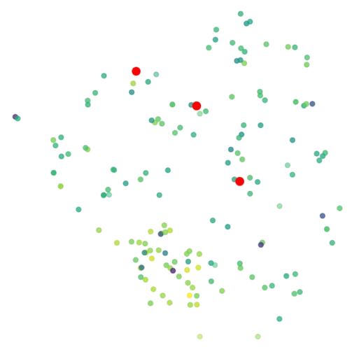
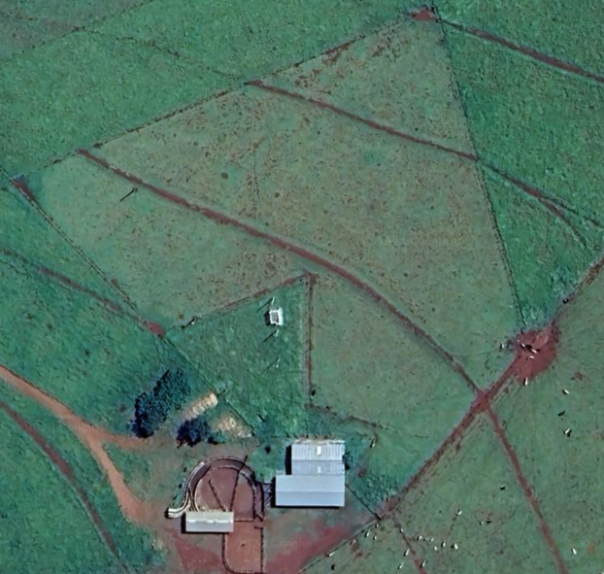
Table of Contents
Introduction 2
Descriptive Analytics Insights 2
Rainfall 2
Impact of Rainfall on Vegetation and Biomass 3
Identifying Optimal Forage Areas with Low ADF and NDF 3
Dry Matter Content 4
Distinct Peaks and Geographic Insights in Reflectance Bands 5
Dew Point, Longwave Radiation, and Evaporation 5
Rainfall and Environmental Stability: A Positive Correlation 6
S-Type Samples: High Biomass, Absence of Animals 6
Biomass and Animal Distribution with Satellite Image Overlay 7
Role of Descriptive Analytics Techniques in Decision-Making 7
Measures of Frequency 7
Measures of Central Tendency 7
Measures of Dispersion 7
Measure of position 8
Outlier Detection 8
Measure of association 8
Visual Representations 8
Predictive Analytics 8
LinearRegression with Lasso Feature Selection 8
LinearRegression with $SelectFromModel$ Feature Selection 9
Time Series Model Using Exponential Smoothing 9
Artificial Neural Network using LSTM 10
LSTM 10
LSTM with SelectKBest Feature Selection 10
LSTM with Multiple Random States 11
Role of Predictive Analytics Techniques in Decision-Making 11
Perspective Analytics 11
1. Selection: 12
2. Crossover: 12
3. Mutation: 12
4. Clearing Duplicates: 12
5. Calculating Cost/Fitness: 12
6. Sorting: 13
Obtaining the Final Weights ($w1, w2, w3$): 13
Role of Prescriptive Analytics in Decision-Making 13
Reference list 13

Introduction
This report contains the result of analyzing pasture biomass production data in the Brazilian Cerrado using satellite remote sensing and laboratory chemical data. This report contains multiple analytical techniques, including descriptive, predictive, and perspective analytics. Multiple visualizations were produced for finding insights during the descriptive analytics phase. In the predictive analytics phase multiple models were discussed and compared with an LSTM model being the best at predicting the biomass. Lastly, I will discuss the perspective analytics part of this project and how the final weights were calculated using Genetic Algorithm and will discuss the role of perspective analytics in decision making.

Descriptive Analytics Insights

Rainfall
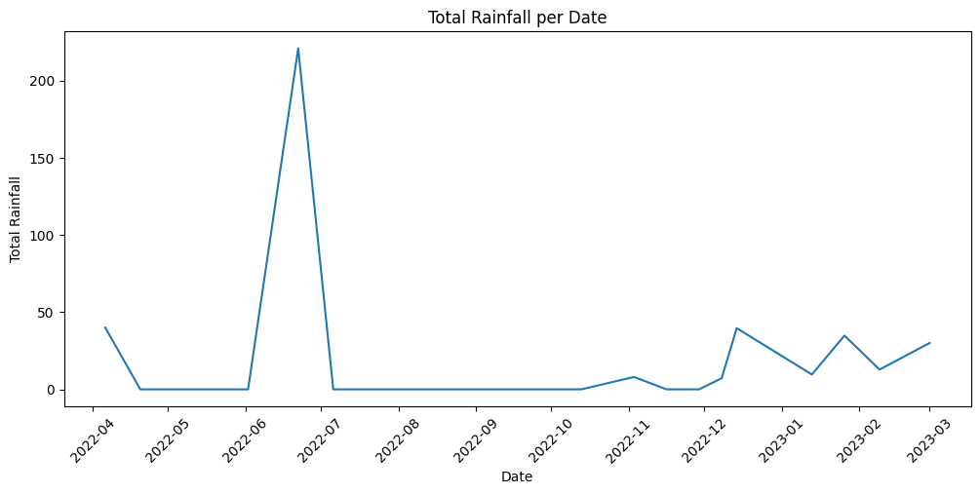The dates: 2022-12-14, 2023-01-1, 2023-01-26, 2023-02-09, 2023-03-0, and 2022-04-06 , showed the highest consistent rainfall, this shows a strong seasonal event that we can benefit from by analyzing the data furthermore. But surprisingly 2022-06-22 showed the highest rainfall in all of the collected data.

Impact of Rainfall on Vegetation and Biomass
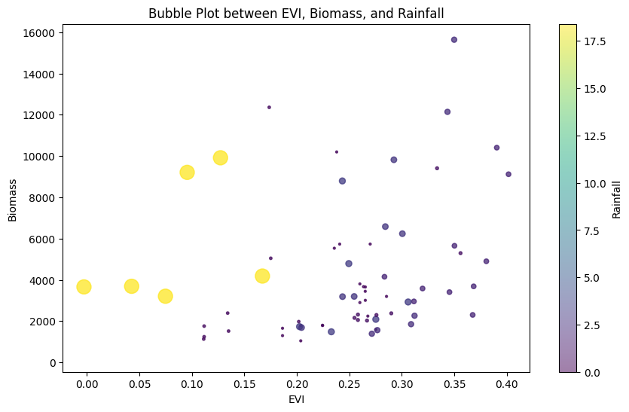
This bubble chart shows the relation between the $Enhanced Vegetation Index \left(EVI\right)$, $Biomass$, and $Rainfall$. From this bubble plot we can understand that when there is too heavy rain the vegetation index is lower, we can make an insight from this as follows:
‘Planting less plants while rainfall is heavy is better than planting plants in heavy rain.’

Identifying Optimal Forage Areas with Low ADF and NDF
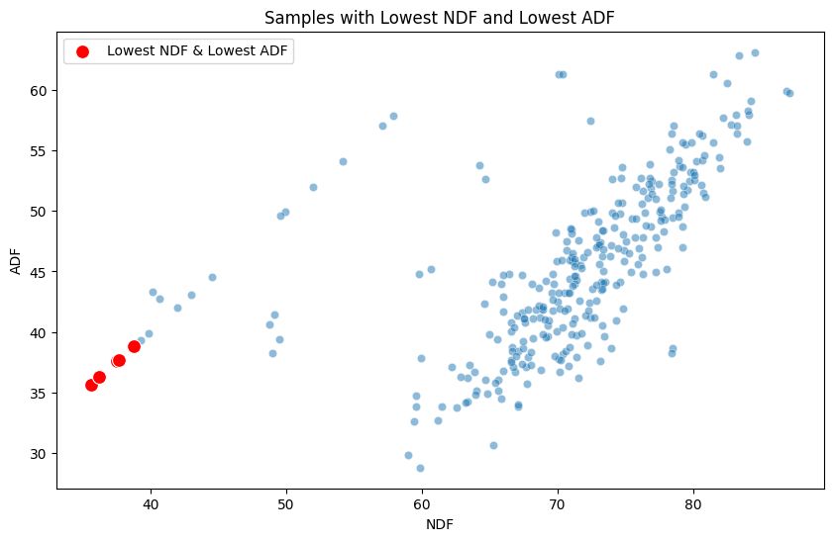
Generally, low Acid Detergent Fiber (ADF) and low Neutral Detergent Fiber (NDF) are preferred for better digestibility, higher energy, and optimal forage intake, which are crucial for livestock performance (Schick, 2023).
To find the best areas that have these features I made this scatter plot to find which areas have the lowest NDF and ADF at the same time.

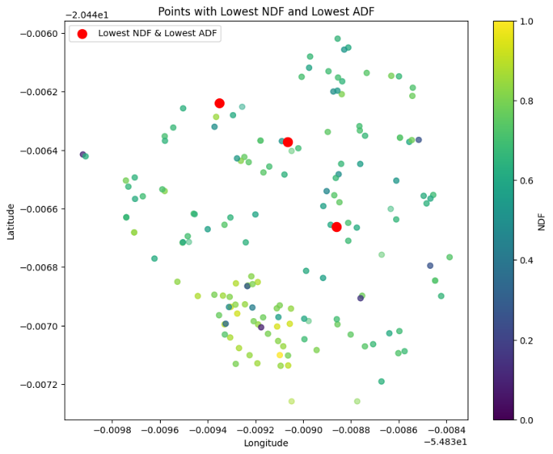
Then I made the following scatter plot that shows exactly where these areas are, these areas shown in this plot show the lowest NDF and ADF, which means that they have higher energy, and optimal forage intake, which are crucial for livestock performance.

Dry Matter Content
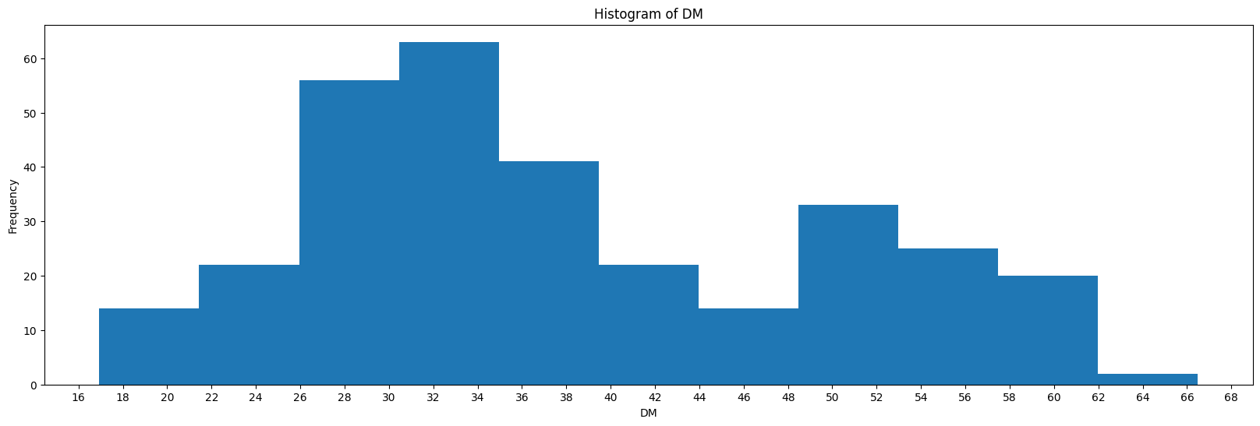The most frequent Dry Matter Content (DMC) is 26%-35%, indicating that the forage provides a moderate balance of nutrients and moisture, suitable for livestock nutrition.

Distinct Peaks and Geographic Insights in Reflectance Bands
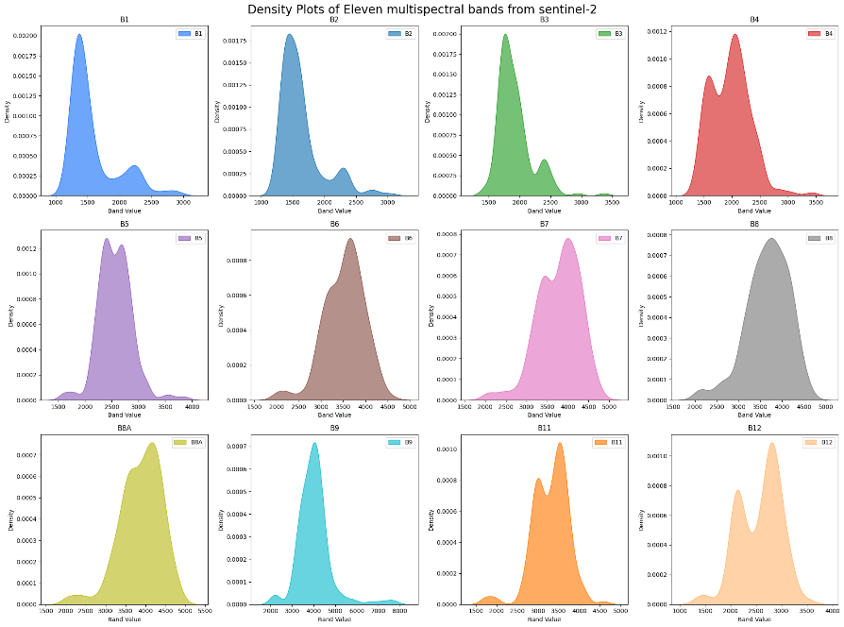
Distinct Peaks in Bands: Each band shows distinct density peaks, indicating specific ranges of reflectance values dominate in different spectral bands.
Wide Range of Values: Bands like B8 and B8A have broader peaks, suggesting higher variability in their reflectance values, potentially indicating vegetation or surface water.
the most frequent latitude and longitude values for the B8 band are (-20.446630, -54.839741), respectively. They showed 4 times, this might suggest that this area has a high reflectance for the range of frequency between 3500hz and 4500hz, for the B8 bandwidth.

Dew Point, Longwave Radiation, and Evaporation
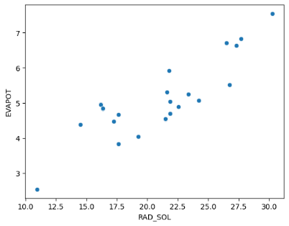
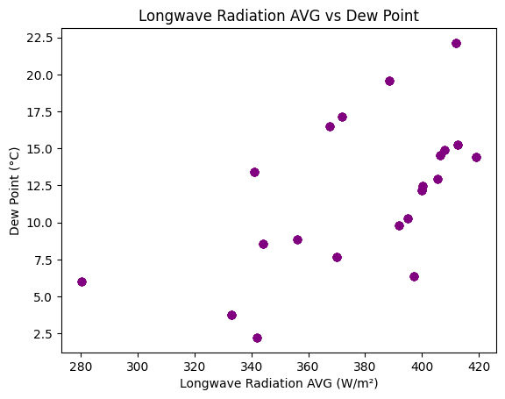
The dew point is the temperature the air needs to be cooled to (at constant pressure) in order to achieve a relative humidity (RH) of 100%. At this point the air cannot hold more water in the gas form.
Longwave radiation refers to energy emitted by Earth's surface, atmosphere, and clouds, primarily as infrared radiation.
There is a linear relationship between Longwave Radiation AVG and Dew Point, the linear relationship confirms that humidity amplifies the greenhouse effect, where more water vapor leads to greater absorption and re-emission of infrared radiation in the atmosphere, creating warmer and more favorable conditions for biomass growth.
We can conclude from plot on the side that the higher the solar radiation, the higher the evapotranspiration. This could mean that where more solar radiation is received, more water is lost through evaporation and plant transpiration-both factors highly relevant to the management of water resources and the conduct of agriculture.

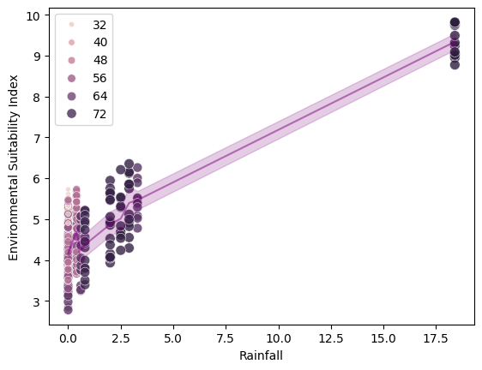
Rainfall and Environmental Stability: A Positive Correlation
There is a clear positive relationship between rainfall and the Environmental Suitability Index, indicating that higher rainfall contributes to a more stable environment capable of sustaining animals.

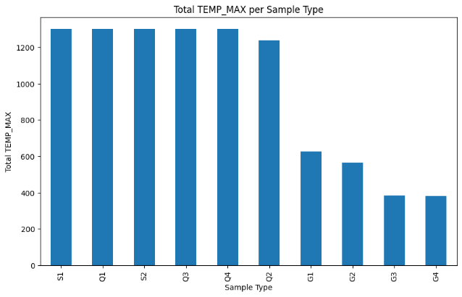
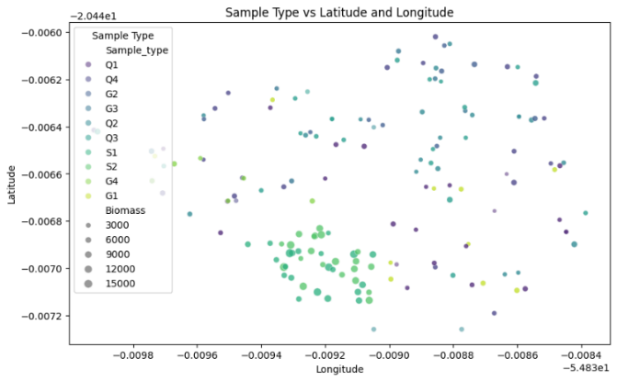
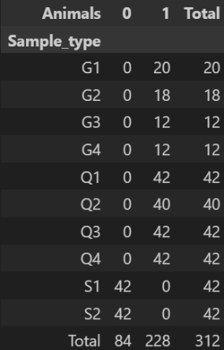
S-Type Samples: High Biomass, Absence of Animals
Only S-type samples lacked animals, and areas without animals’ record. And S1, S2, Q1, Q3, Q4 type samples showed the highest summed temperatures.

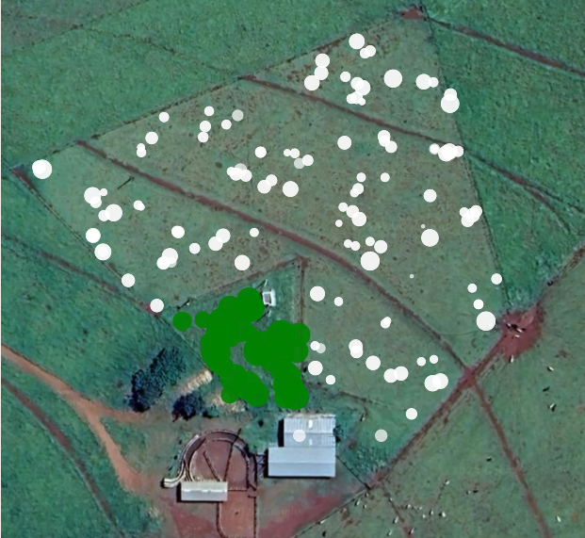
Biomass and Animal Distribution with Satellite Image Overlay
Biomass Distribution with Satellite Image Overlay (White=Animals, Green=No Animals, Size=Biomass)
This picture shows Animals distributed over the field: the white area shows where an animal is allowed to be, and the green area is where animals are not allowed. The size of the bubbles shows the biomass. We can see that no-animal areas have bigger biomass values-that means restricted areas have higher biomass due to undisturbed growth, and areas of grazing show lower biomass, highlighting the effects of grazing on vegetation.

Role of Descriptive Analytics Techniques in Decision-Making

Measures of Frequency
When I did a frequency analysis of Dry Matter Content (DMC) I found that the most frequent DMC percentage is 26%-35%, which indicates most of the analyzed samples had a moderate proportion of solids relative to water content. According to (www.dairynz.co.nz, 2023) a DMC of 26-35% in pasture is considered typical for fresh, high-quality forages. This range indicates that the pasture is in good condition and will be nutritionally adequate for grazing livestock.
Analyzing the frequency of each band showed distinct peaks in each band. Each band shows distinct density peaks, indicating specific ranges of reflectance values dominate in different spectral bands.

Measures of Central Tendency
Using measure of central tendency did not provide me with any new insights, it just gave me additional information, like, the most frequent sample type was $Q1$ which appeared 42 times, and that the mean of biomass is $4302.$

Measures of Dispersion
Using the measure of dispersion, I was able to understand how the data is distributed, I understood the range of values for the Biomass. Using the variance, I understood what the variance between sample readings of the NDF is. In general, the measure of dispersion helped understand the data itself, rather than helping me find new insights.

Measure of position
Using the measure of position helped me find out that ADF follows a normal distribution.

Outlier Detection
I found out that multiple features in the data have outliers, for example the bandwidth number 1 ‘B1’ had the most outliers among all other features with 50 outliers, the TEMP_MAX column had 48 outliers. Outlier detection generally helped me in the work just to remind myself to keep in mind that some of the features have outliers. It made me be precise with my future investigation of data to not get misled by an outlier.

Measure of association
Using a contingency table of the ‘sample type’ and the availability of ‘animals’, I was able to find out that all the sample had animals in the areas they were taken from, except for sample types: S1, and S2. This opened the door for more investigation that led me to the conclusion that fields with no animals have higher biomass compared to the fields that had animals on them.

Visual Representations
Using visualizations was the most beneficial technique to find patterns and insights. For example, a bubble plot between EVI, Biomass, and Rainfall helped me figure out the insight that is: when there is too heavy rain the vegetation index is lower, thus planting less plants while rainfall is heavy is better than planting plants while heavy rain.
Another useful visualization is the scatter plot between NDF and ADF, this plot helped me find the samples with the lowest NDF and lowest ADF, these points indicating that they have higher energy, and optimal forage intake, which are crucial for livestock performance. Then I used another plot to find the exact coordinates of these samples to find the best forage areas for the animals.

Predictive Analytics

LinearRegression with Lasso Feature Selection
After doing feature selection using Lasso Feature Selection, I used cross-validation over 5 K-Folds with multiple randoms states to be confident of the results.
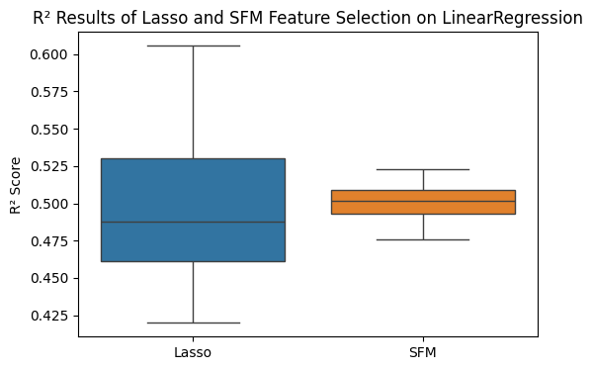
The best $R^{2}$ I got from all the trials is $60.56\%$ which is not a very high $R^{2}$

LinearRegression with $SelectFromModel$ Feature Selection
After doing feature selection using SelectFromModel Feature Selection, I used cross-validation over 5 K-Folds with multiple randoms states to be confident of the results.
The best $R^{2}$ I got from all the trials is $52.27\%$ which is again not a very high $R^{2}$ and it is even worse than Lasso technique.
Using Lasso for feature selection provided better data for LinearRegression model, rather than SelectFromModel

Time Series Model Using Exponential Smoothing
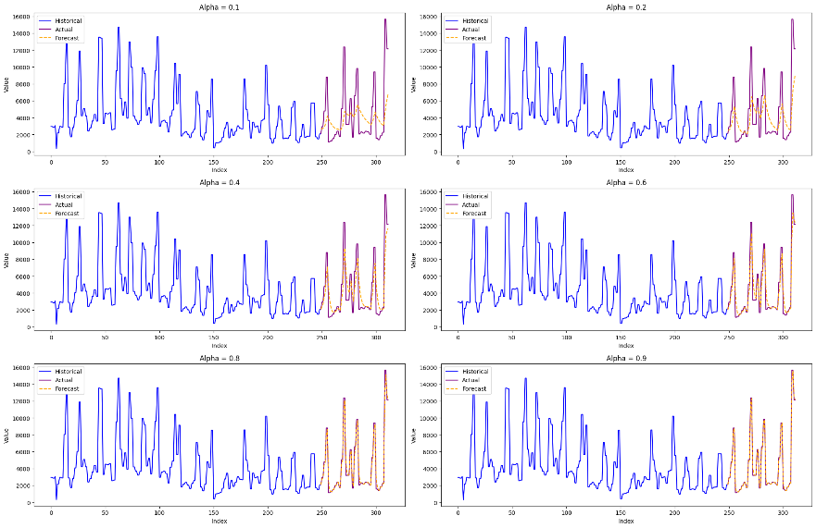
The following figure shows the difference between multiple $alpha$ values for forecasting, high values like $0.9$ show that the model captures the actual data to a degree that it is overfitting the data, this is not a good sign if we want to use exponential smoothing for future years forecasting, as this will predict values very similar to the previous year; which is not correct most of the time.
Figure 2: difference between multiple $alpha$ values for forecasting
Values like $0.4$ to $0.6$ still capture the patterns and the general trends without overfitting the actual values.

Artificial Neural Network using LSTM

LSTM
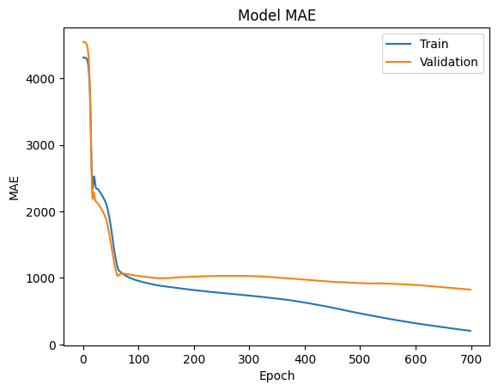
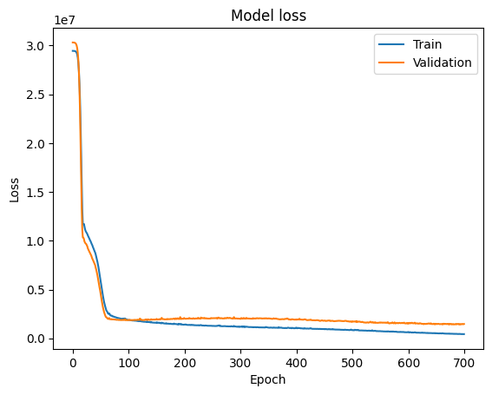
For building the neural network I used an LSTM model (Long Short-Term Memory), at first, I tried the network by itself with all the features in the data without feature selection, but I still did scale the data using MinMaxScaler to fit the data between [0,1]; because neural networks work better at that scale. The final results of this model were actually good with an $R^{2}$ of $87.2\%$ and a mean absolute error of $901.68$. the model was trained for 700 epochs and the plots to the side shows the MAE and loss (MSE) while training this model.

LSTM with SelectKBest Feature Selection
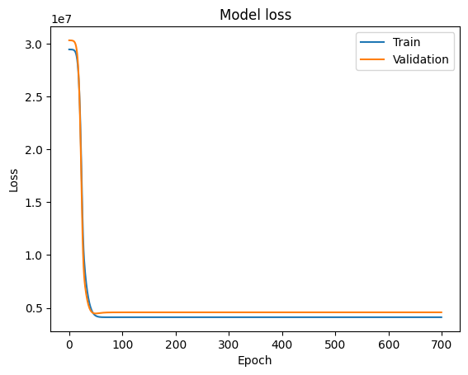
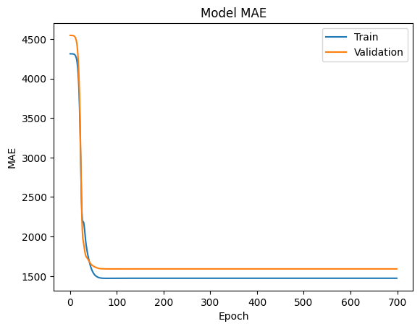
I tried the LSTM model with feature selection using SelectKBest. I set the k to 10 and the model chose the best 10 features, surprisingly, all of them where sample types from the encoded samples. The model did not perform very well, in fact, it performed worse than LSTM without feature selection. The $R^{2}$ was $63.84\%$ and the MAE was $1521.86$.

LSTM with Multiple Random States
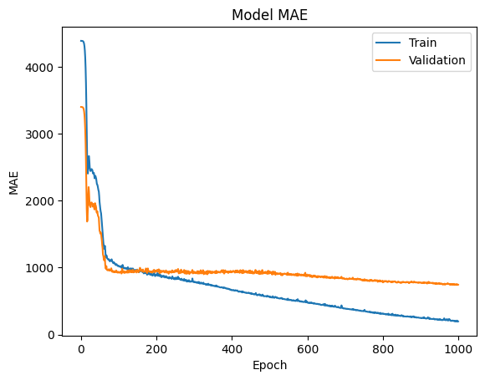
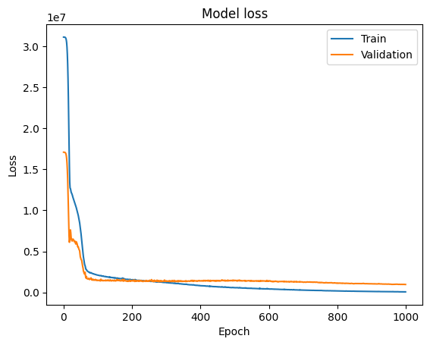
At last, I trained the LSTM model again but using multiple random states to ensure model consistency and to select the best model, I trained the model 5 times on 1000 epochs without feature selection. The final results were as follows: $R^{2}$ was $91.48\%$ and MAE was $491.2$, this is the best model ever between all the mentioned trained models, this shows how much the random state, and the epoch size really affect the models’ performance.

Role of Predictive Analytics Techniques in Decision-Making
From the created machine learning models, we can predict the future of the biomass in the studied area, this can help farmers develop strategies on planting and harvesting time. Biomass predictions will allow farmers to plan days in advance when plants are going to have a particularly productive day or help find out which areas are most likely to underperform.
From the developed models a LSTM that selected from multiple random states performed the best, with an $R^{2}$ score of $91.48\%$ using this model will give the best results for predicting future biomass.

Perspective Analytics
In the last iteration of the implementation of the Genetic Algorithm (GA), the various evolutions were applied through the following steps: selection, crossover, Mutation, clearing duplicates, sorting, and calculating cost. The following is a detailed breakdown of the steps:

1. Selection:
During the selection process individuals are chosen from the population to represent the parents of the next generation. The selection parents were selected based on random selection while preferring parents with higher fitness values. For example, of the selected parents were: [0.27936118 0.05197518 0.15094861] and [0.43382725 0.27037751 0.85333765]

2. Crossover:
After selecting the parents, a crossover between them happens based on a random point. For example: crossover between [0.27936118 0.05197518 0.15094861] and [0.43382725 0.27037751 0.85333765] produced [0.43382725 0.27037751 0.85333765] and [0.27936118 0.05197518 0.15094861]. This process is repeated multiple times.

3. Mutation:
Now that the crossover between the parents is over it is time to mutate them into multiple new forms to create new individuals. The mutation is based on random index, this is done to ensure genetic diversity. An example of mutation is as follows: before mutation [0.27936118, 0.14457443, 0.07190834] after mutation [0.27936118, 0.14457443, 0.14828086]

4. Clearing Duplicates:
Once the crossover and mutation steps are done, duplicates are removed from the population from the experiment report, it states that 7 duplicates were cleared from the population.

5. Calculating Cost/Fitness:
The fitness of each individual in the population is then calculated, here is an example of the fitness values of multiple individuals:
Individual [0.012733 0.05197518 0.07190834] has fitness 10.179347383546116
Individual [0.012733 0.14457443 0.20193606] has fitness 1.5217870874533435
Individual [0.012733 0.21139638 0.295203 ] has fitness 5.834823396985601
Individual [0.03305873 0.3653795 0.07190834] has fitness 48.243596033269746
- Fitness values represent how well an individual performs the given task and sorting them allows for selection of the fittest individuals for reproduction in the next iteration.
- The fitness values are calculated based on the weights w1, w2, and w3 and how well they solve the problem the GA is designed to address.

6. Sorting:
Finaly, the individuals are sorted by their fitness values to determine which individuals will continue to the next generation. For example, at iteration 50 the best fitness is 0.427829795364683, it was this individual: [0.27936118 0.14457443 0.07190834].

Obtaining the Final Weights ($w_{1}, w_{2}, w_{3}$):
At the end of the 50th iteration, the GA reaches its final solution, which is the set of weights that minimizes the objective function which is the Mean Squared Error (MSE). And as mentioned before the final selected weights from the 50th iteration is:
$$w_{1}=0.27936118$$
$$w_{2}=0.14457443$$
$$w_{3}=0.07190834$$

Role of Prescriptive Analytics in Decision-Making
Perspective analytics helps find the course of action for a certain situation. In my work, perspective analytics was used to find the best weights for Rainfall, Max Temperature, and Vegetation Index, I needed these weights to find the best course of action in order to understand the Environmental Stability Index. Using optimization algorithms, like Genetic Algorithm, I was able to find these weights, these weights tell us which feature importance has more, in other words, which feature has more impact on the environmental stability index, understanding these results help find the best course of action and recommendations for a given situation.

Reference list
Schick, B. (2023). Pasture and Forage Minute: Understanding ADF and NDF, Hay Quality After Calving | CropWatch | Nebraska. [online] Unl.edu. Available at: https://cropwatch.unl.edu/2023/pasture-and-forage-minute-understanding-adf-and-ndf-hay-quality-after-calving/.

